Daniel Fryer
Assignment 4.2 sitka
2/5/2026

Original program flow
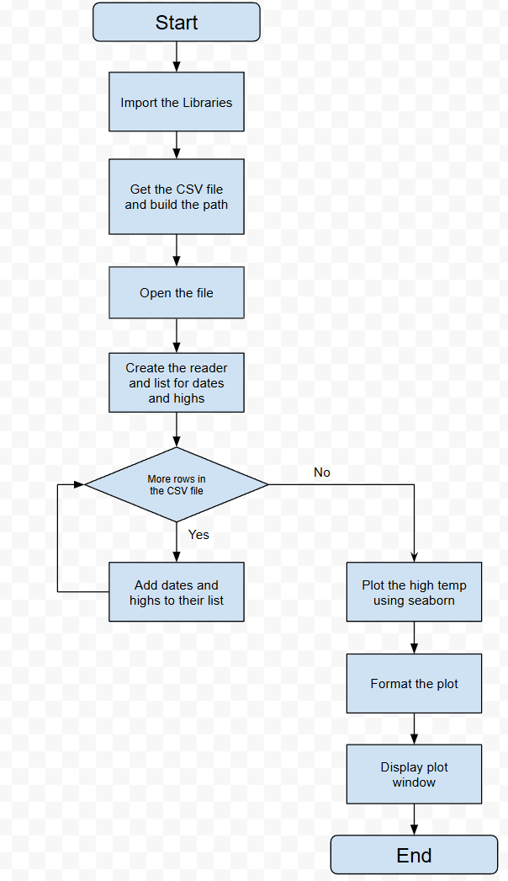

Updated program flow
